Project 1: Analysis of a Parallel Hybrid Electric Vehicle

TJ Wiegman

2023-02-10

In this project, the power flow through a parallel hybrid electric vehicle was modeled and analyzed in Simulink. The internal combustion engine (ICE) is used for sustained operation and always operates in its optimum fuel efficiency regime, while the electric power systems are used only for launch, boost, and regenerative braking. Throughout three common drive schedules, the simulated vehicle’s ICE and electric power systems were monitored, and the model provided reasonable and realistic results.

## Introduction

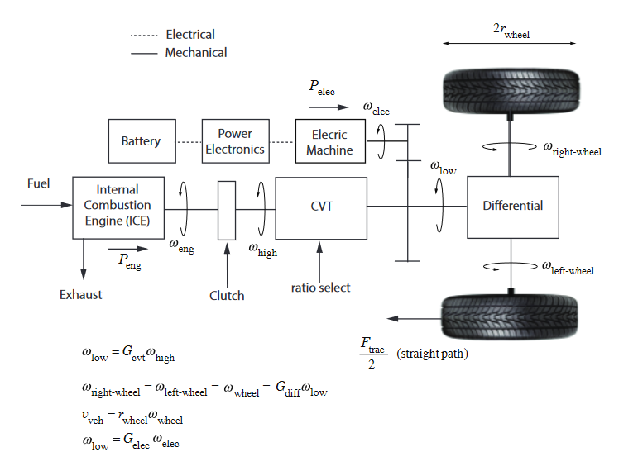

Figure 1: The system architecture of the parallel hybrid electric vehicle. The electric motor/generator is connected to the driveshaft between the continuously variable transmission (CVT) and the differential. Image Credit: Alothman (2023).

## Methods

## Results & Analysis

## Discussion

## References

Alothman, Maryam. 2023. “ECE 51018 Project 1 Instructions.”